**Title An invasive buzz pollinated weed is self-compatible and can reproduce asexually.**

**Authors f**

**Journal** *Biology letters* (research article – 3500 words + electronic supplementary material; max 3 figures + 3 tables; cover letter should also be uploaded to support your submission and that states why your research is novel; no page or colour charges)

*check SIMPLE PAST TENSE before sending and include citations/references.*

**Abstract (200-word limit)**

*Theoretically, specialist mutualisms pose a barrier to plant invasions, yet we have some highly invasive plants that have specialist pollinator mutualisms. .* We assessed whether, and to what degree, *S. obtusifolia* is (1) physiologically self-compatible and (2) functionally self-compatible. We also assessed whether (3) *S. obtusifolia* is pollen limited in either of its native or non-native regions studied. Hand-pollination experiments were done in one native and one invasive region to determine the breeding system. Six treatments were applied to plants in each region, manipulating pollinator access, pollen availability and pollen supplemented with donor pollen from the same plant or a different plant in the same population. ***Senna obtusifolia* presented a mixed mating system and it was both physiologically and functionally self-compatible. It produced a high degree of fruit and seed when exposed to self-pollen in both its native and non-native ranges. *S. obtusifolia* could reproduce in the absence of pollinators in both its native and non-native ranges; however, few viable seeds were produced from flowers where pollen was excluded. *S. obtusifolia* was not pollen-limited in the native range, but fruit set from the open pollination treatment was significantly less than from the emasculate closed treatment in the invasive range, indicating that it was pollen-limited in the invasive range. Our results provide support for the reproductive assurance hypothesis, because uniparental reproduction has likely contributed to the invasion success of this species when it is introduced to new world regions.**

**Keywords (min. 3)** uniparental reproduction; reproductive assurance

**Introduction**

A plethora of research attempts to predict what general traits invasive species have in common to aid better management of invasive species. Invasion syndromes are a combination of pathways, alien species traits, and characteristics of the recipient ecosystem that collectively results in predictable dynamics and impacts of invasive species (Novoa et al. 2020; building on Kueffer *et al.* 2012 definition). The accuracy of invasive risk assessment protocols remains insufficient because we lack empirical studies that enable broad trends and generalizations, which are needed for invasion syndromes, to be drawn. For example, it has been hypothesized that plants with generalist pollination syndromes are more likely to become invasive compared to plants with specialist pollinators (Richardson…). Yet few studies have directly assessed whether specialisation poses a barrier to plant invasions (Rodger?) and what factors facilitate invasion success for the species that have overcome this theoretical barrier (ref).

One difficulty is that the definition of generalist or specialist pollination can vary (discussed in depth in Armbruster 2017). Here, we use “phenological” specialisation, because invasive traits used in pollination syndromes tend to align with the floral characteristics (ref). Invasive angiosperms typically have large floral displays, showy flowers, and large amounts of floral rewards, making them attractive to a broad number of pollinator functional groups and species (Parra-Tabla and Arceo-Gomez 2021). Despite this, globally some phenotypically specialised plants have become highly invasive.

Poricidal anthers are one such specialised floral morphology that have evolved in an estimated 10% of angiosperms and restrict pollen access (ref.). To efficiently extract pollen from poricidal anthers, an insect will vibrate its thorax muscles to produce an audible frequency which causes pollen release (). This coevolution between “buzzing” pollinators and poricidal anthers is known as the buzz-pollination syndrome. Globally, there are 94 angiosperm species that have poricidal anthers and have become highly invasive (reviewed by Lopresti *et al.* 2024). Yet, we are at the early stages of understanding what traits facilitate plant invasions for species with the buzz pollination syndrome.

One strategy to overcome the barrier of matching with a pollinator when introduced to a new region may be to reproduce in the absence of pollinators (Traveset). The reproductive assurance hypothesis predicts that selection favours self-pollination or asexual reproduction in flowering plants where pollinators or mates are scarce (Darwin, 1876; Baker, 1955), such as when colonising new habitats (Baker, 1955). Baker’s Law reiterates the reproductive assurance hypothesis and states that uniparental reproduction is advantageous for species when colonising new regions over large distances (Baker, 1955; Stebbins, 1957). Most invasive species have mixed mating systems (Korpelainen and Pietiläinen 2023); that is, plants which can reproduce from the same parent which is beneficial under low population densities. However, few studies have compared the reproductive biology in both the native and non-native range for an introduced species with specialist floral morphologies to assess how these plants overcome the theoretical barrier of having specialist pollinators.

In this study, we aim to assess the breeding system of an alien invasive plant with specialist floral morphology. *Senna obtusifolia* (Fabaceae) has poricidal anthers and exhibits the buzz pollination syndrome. *Senna obtusifolia* is native to the tropical Americas and has been introduced to every other continent except Antarctica. It has established and become invasive across much of the world’s tropical regions, including in Australia. Yet, the reproductive biology of *S. obtusifolia* in either the native or introduced ranges are largely unknown.

We addressed the following specific questions: (1) to what degree is *S. obtusifolia* physiologically self-compatible, (2) to what degree is *S. obtusifolia* functionally self-compatible, and (3) is *S. obtusifolia* pollen limited in either of its native or non-native ranges. We expect that *S. obtusifolia* can reproduce with self-pollen (physiologically self-compatible) and in the absence of pollinators (functionally self-compatible); and that selfing rates are higher in the invasive range compared to the native range. Further, we expect that *S.* *obtusifolia* will be pollen limited only in the non-native range.

**Methods**

*Study Sites*

This study was conducted *in situ* over one flowering season in each of *S. obtusifolia*’s native and non-native ranges. Native populations were studied between September and November 2023, at three sites in Yucatan, Mexico: Chochola, Tekik de Regil and Xmatkuil. Non-native populations were studied between April and August 2022, at five locations in Queensland, Australia: White Rock, Kamerunga, Trinity Beach, Springvale Station Nature Refuge and the West Normanby River (Table S1). Populations contained at least 50 *S. obtusifolia* plants. In the native range, populations were interspersed in plant communities that were dominated by *S. uniflora* on disturbed riparian corridors or farmland. In the non-native range, populations typically formed a monoculture, also on disturbed habitat riparian corridors or farmland.

*Breeding* ***system***

To determine the breeding system of *S. obtusifolia*, a series of pollination experiments were applied to 20 plants at each site. Flower buds near to opening were haphazardly selected and subjected to one of six randomly selected treatments: (1) open control (exposed to natural pollinators), (2) pollinator exclusion (mesh exclusion), (3) emasculated open (pollinator access without self-pollination), (4) emasculated closed (to test for apomixis and act as a control to emasculation treatments), (5) emasculated outcrosser (emasculate, bag to exclude natural pollinators, and hand pollinate with outsourced pollen), and (6) emasculated selfer (emasculate, bag to exclude natural pollinators, and hand pollinate with pollen sourced from the same individual). Each treatment was applied to an individual plant in the native range, while all of the six treatments were applied to the same plant in the non-native range and replicated on 20 plants per population because the plants were smaller which prevented all six treatments to be applied to the same single plant in the native range. Treatments 3-6 were not applied at Springvale or the Normanby River populations due to time constraints. To ensure synchronicity of stigma receptivity within and among the treatments, flowers on a given plant were selected on the same day for all six treatments. White fine mesh bags (20 cm x 30 cm, or 16 cm x 23 cm) were used to exclude floral visitors during the experiment.

The open control was tagged and not manipulated. The pollinator exclusion treatment was bagged and not further manipulated. Emasculated open involved removing the anthers with foreceps prior to the stigma being receptive and the flower remained open to natural pollinators. Emasculated closed flowers also had the anthers removed prior to stigma receptivity and the flower was bagged. Emasculated outcrosser and emasculated selfer involved bagging the bud prior to flowers opening, and then hand pollinating each flower. Donor pollen was sourced on the day of hand pollination for the emasculated outcrosser and emasculated selfer treatments from flowers that had not been assigned a pollination treatment, from individuals at least 10 m away in the same population, or the same plant, respectively. Flowers were picked, and pollen was released using an electric toothbrush (Tayal *et al*., 2020). Released pollen was brushed onto the receptive stigma and pollen deposition was confirmed by visual inspection through a hand lens. Bags that were compromised during the experimental period, such as those where the branch broke, the bag tore, or there were signs of insect activity (such as frass), were excluded from the final analysis.

All flowers were monitored for reproductive success from the time of pollination to pod maturation. The pod was classed as mature when a colour change was observed, and the pod was near to splitting. *Senna obtusifolia* pods matured within two months of pollination. Mature pods and seeds from each site were collected and counted to determine the number of seeds per pod. Seeds were classed as aborted (where the seed looked malformed) or viable. Reproductive success was defined as: 1) the percentage of flowers that produced a pod, and 2) the count of viable seeds per flower.

*Statistical analysis*

All data analyses were done in R (version 4.4.0). Due to differences in the field methods, we statistically analysed the data from each range independently and compared the results between the ranges qualitatively.

To examine whether fruit set varied among treatments we undertook two generalised linear mixed models with a binomial link function. Treatment was the predictor variable and fruit set was the response variable. For the native range data, we included site as a random effect. For the invasive range data, plant was nested in site and included as a random effect. We included an optimizer using a quadratic approximation to ensure the invasive range model converged. A Tukey HSD analysis was undertaken on each model to determine where the differences lay.

To determine whether seed set significantly differed among treatments we undertook an additional three generalised linear mixed models. In each model seed count per flower was the response variable and treatment was the fixed factor. The native range data was zero inflated so we used a negative binomial link function for this analysis. Further, in the native range one site (Chochola) had a much higher rate of zeros compared to the others. Consequently, we ran two analyses on the native range data and included site in both models as a zero inflated factor. For the first model we also included site as a fixed factor. This first model showed no significance difference among sites so we excluded site as a fixed factor from the second model. The AIC values demonstrated that the second model was the best fit for the data, so in this manuscript we present the results from the second model only: seed count per flower was the response variable and treatment was the fixed effect and site was included as a zero inflated variable. We undertook pairwise comparisons on select treatments to determine where the significant lay. We undertook a third GLMM with a Poisson distribution on the invasive range data. We included plant nested in site as a random effect and treatment was included as a zero inflated factor. We did a Tukey HSD analysis on this final model to determine between which treatments the differences lay.

**Results**

***Breeding system***

Fruit was produced at least once in all pollination treatments, although the proportion of flowers that set fruit varied broadly (Tables 1, S2, and S3; Fig. 1). In the native range, significantly fewer fruits were set when pollinators were excluded from the flowers (pollinator exclusion and emasculated closed) compared to other treatments, all of which were exposed to natural pollinators or artificially pollinated. In the native range there was no significant difference in fruit set between the open control and emasculate outcross treatment indicating *S. obtusifolia* was not pollen limited. Further, in the native range, the proportion of flowers that fruited from the emasculate selfing and emasculate outcross treatments did not significantly differ, demonstrating that *S. obtusifolia* has high levels of self-compatibility.

Similarly, in the invasive range some fruits were produced when pollinators were excluded from the flowers (pollinator exclusion and emasculate closed treatments) although, overall, fewer fruits were set from these treatments in the invasive range (<10%) compared to the native range (~25%) (Table 1; Fig. 1). In the invasive range, flowers exposed to natural pollinators set significantly fewer fruits compared to the emasculate outcross treatment, indicating that *S. obtusifolia* was pollen limited in the invasive range. Yet, there was no significant difference in fruit set between the emasculate outcross and emasculate selfing treatment demonstrating that *S. obtusifolia* is fully self-compatible. Interestingly, over half the flowers from the emasculate selfing treatment produced fruit in the native range, while less than one quarter of flowers from this same treatment produced fruit in the invasive range (Fig. 1).

The number of viable seed produced by each flower varied among treatments (Table 1, and S4; Fig. 2). In the native range, flowers produced on average eight viable seeds when exposed to natural pollinators, which did not significantly differ from the hand pollinated outcross treatment. However, flowers that exposed to pollen from the same plant (emasculate selfing) produced significantly fewer seeds compared to those that were pollinated with outcross pollen (emasculate outcross). On average, at least two seeds were produced per flower when the pollinators were excluded from the flowers (pollinator exclusion and emasculate closed) in the native range, and seed set did not significantly differ between these treatments. (Fig. 2).

In the invasive range, each flower produced on average ten seeds when exposed to natural pollinators, which did not significantly differ from flowers which were hand pollinated (emasculate outcross and emasculate self treatments) (Fig. 2). Fewer viable seeds were produced when pollinators were excluded from the flowers (pollinator exclusion and emasculate closed), although, overall, seed set within these treatments was highly variable (Fig. 2).

Table 1. Summary of results from the generalised linear mixed models for each response variable in each range.

|  |  |  |  |  |  |
| --- | --- | --- | --- | --- | --- |
| **Response variable** | **Range** | **Effect** | **Chisq** | **DF** | **Pr(>Chisq)** |
| Proportion fruited | Native | Treatment | 30.39 | 5 | <0.001 |
| Proportion fruited | Invasive | Treatment | 69.45 | 5 | <0.001 |
| Seed count (per flower) | Native | Treatment | 12.25 | 5 | 0.031 |
| Seed count (per flower) | Invasive | Treatment | 33.12 | 5 | <0.001 |

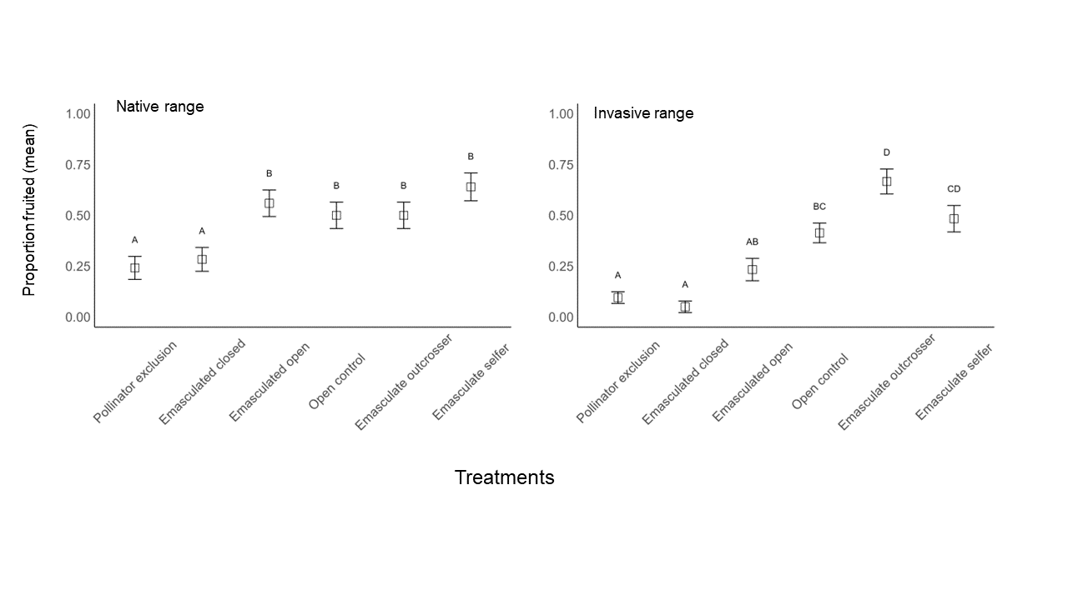**Figure 1. The mean (+-SE) proportion of flowers that set fruit after exposure to one of six pollination treatments. Data are pooled across sites within each range. Within each range, bars with different letters are significantly different, according to Tukey HSD analysis after a generalised linear mixed model.**

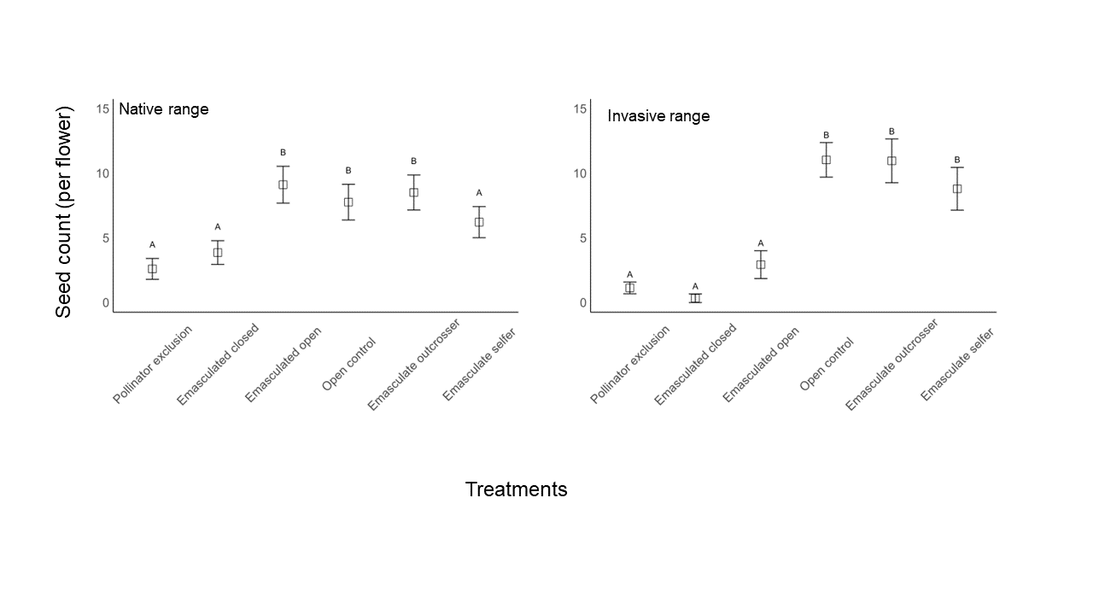**Figure 2: Mean (+-SE) count of seeds per flower after exposure to one of six manipulative pollination treatments. Data is pooled across sites within each range. Within each range, bars surmounted with different letters are significantly different, according to pairwise comparison where pollinator exclusion is the reference level (native range) and Tukey HSD analysis (invasive range) after a generalised linear mixed model.**

**Discussion**

***~~Senna obtusifolia~~* ~~presented a mixed mating system and it was both physiologically and functionally self-compatible. It produced a high degree of fruit and seed when exposed to self-pollen in both its native and non-native ranges.~~ *S. obtusifolia* could reproduce in the absence of pollinators in both its native and non-native ranges; however, few viable seeds were produced from flowers where pollen was excluded. *S. obtusifolia* was not pollen-limited in the native range, but fruit set from the open pollination treatment was significantly less than from the emasculate closed treatment in the invasive range, indicating that it was pollen-limited in the invasive range.**

*~~Senna obtusifolia~~* ~~has a mixed mating system and was self-compatible. Viable seeds were produced when the flowers were self-pollinated, providing evidence that~~ *~~S. obtusifolia~~* ~~is physiologically self-compatible. This may contribute to~~ *~~S. obtusifolia’s~~* ~~success as an invader because it did not need pollen from a different plant to reproduce~~. Our results align with the reproductive assurance hypothesis, which predicts an increase in selfing rates when mates or pollinators were scarce (Darwin, 1876; Baker, 1955), such as when colonizing new environments over long-distance dispersal (Baker, 1955). However, *S. obtusifolia* was enantiostylous (mirror image floral morphology and the stigma is deflected to one side) (ref.). There is evidence that enantiostyly has evolved to reduce self-pollination in wild populations (*in Moirais 2020: check which are wild studies Fenster 1995; Barrett et al. 2000; Carvalho & Oliveira 2003; Westerkamp 2004; Laporta 2005*). The relative importance of enantiostyly in our system is unknown, but there is an apparent contradiction on the presence of traits that should avoid self-pollination (enantiostyly) or reduce the range of pollinators to an specialised subset (buzz pollination) and the need to reproduce in a newly colonised area, and the increase in self-compatibility rates observed in our study. We could hypothesise that some of these atavic specialised traits might be no longer functional, and could potentially be the object of selection. Detailed studies on the floral morphology, including whether the flowers are monomophoric or dimorphic enantiostylous, would help to determine whether, and how frequently, self-pollination actually occurs in *S. obtusifolia* populations.

The observed shift towards increase selfing in the invasive range compared to the native range is not surprising, because the selection for genotypes that are more self-compatible can be selected for when suitable pollinators or mates are scarce (Petanidou et al. 2012), such as when species are introduced to new regions by long distance seed dispersal (Baker, 1955). Further, other hand pollination experiments have shown that 73% (eight of the eleven Senna and *Cassia* studies which we have data for) can set seed from self-pollen. Yet, none of these studied *Senna* or *Cassia* species have set viable seed in the absence of a pollinator (natural or artificial pollination).

Our study is the first to our knowledge that has provided field evidence for viable seed set when pollinators were excluded from flowers in this genus (functional self-compatibility). Cytogenetic and molecular analyses have shown that some *Cassia* and *Senna* species have a high proportion of asexual offspring and can reproduce by apomixis (Randall 1970; Resende et al. 2014; Holamn and Playford 200; Delnevo et al. 2024). Our result supported our expectation that *S. obtusifolia* can reproduce in the absence of pollinators. Despite being self-compatible and apomictic, pollinators are likely important for the longevity of *S. obtusifolia* populations because significantly more seeds were set when pollen supply was supplemented. or when it was exposed to natural pollinators. compared to the pollinator exclusion treatments.

It is also interesting that the patterns from the seed set data in the emasculate open treatment differed between the two ranges. In the native range, the emasculate open treatment set the same amount of seed compared to those exposed to natural pollinators and those that were hand pollinated; while in the invasive range, pods in the emasculate open treatment set very fewer viable seeds than those which pollen supplemented. This suggested that natural pollinators were attracted to and visited the emasculated flowers in the native range and not in the invasive range. This may be a result of differing pollinator communities between the ranges. In the field, we observed many pollinators damage the flowers when they foraged in the invasive range (e.g., they bit the anthers), which was not a prominent pollinator behaviour in the native range (unpublished data). Future studies could assess whether certain pollinator species learn to avoid damaged flowers over time, and whether *S. obtusifolia* pollinators are still attracted to damaged flowers, to determine whether emasculating the anther altered the visiting pollinator communities.

**~~Hand pollinated flowers produced significantly more fruit compared to those open to natural pollinators in the invasive range, which indicated that~~ *~~Senna obtusifolia~~* ~~was pollen limited in the invasive range only~~. When removed from coevolved pollinators, such as when plants are introduced into new world regions, plants may not attract efficient pollinators. This has potentially contributed to the pollen limitation because there was no difference in fruit set between hand pollinated and natural pollinated flowers in the native range. However, in our study, plants in the invasive range were larger and field observations showed that the larger plants produced more flowers. Consequently, it is unlikely that the minor pollen limitation in the invasive range posed a barrier to reproductive output and consequently, invasion success.**

**Specialist pollination syndromes likely pose a barrier to invasions because the newly introduced species is less likely to attract pollinators when they require a specialist pollinator to reproduce. However, *S. obtusifolia* has overcome this potential barrier and it is invasive. Despite being pollen limited in the invasive range in Australia, nearly half of the unmanipulated flowers produced fruit and likely viable seed. Our result demonstrates that *S. obtusifolia* has found an adequate number of effective pollinators in the invasive range to reproduce and become invasive.**

Our study provided support for the reproductive assurance hypothesis by proving *S. obtusifolia* ability to set seed from self-pollen. We also found that *S. obtusifolia* can set viable seed in the absence of pollinators altogether, which likely contributes to its invasion success. This is particularly important because *S. obtusifolia* exhibits the specialised buzz pollination syndrome. When introduced to a new region, *S. obtusifolia* does not need to find pollinators that can access pollen from poricidal anthers to set seed and reproduce. Finally, our study demonstrated that *S. obtusifolia* was pollen limited in its invasive range, but a prolific amount of viable seed was set, so it is unlikely that pollen limitation prevented newly introduced populations establishing. The next logical steps are to determine whether viable seeds from each treatment here do, in fact, germinate; and whether progeny reared from seed produced asexually or from self-pollen are as fit as seed sourced from outcross pollen.

**Author contributions**

**Acknowledgements field assistants/Abiel.**

**Funding information ATH, CSE, and ATBC grants; Laura C. Lopresti was supported by the Australian Government Research Training Program Scholarship.**

**Ethics statement We were not required to complete an ethical assessment prior to conducting our research.**

**Competing interests statement We declare we have no competing interests.**

**Data accessibility statement The data sets and code generated during the current study are archived in the Research Data Australia repository and are publicly available: *DOI to be added***

**Artificial Intelligence (AI) declaration We have not used AI-assisted technologies in creating this article.**

**References**

**“it was also found that Senna is rather a heterogeneous taxon”**

(Randall 1970; Resende et ai/ 2014; Holamn and Playford 200; Delnevo et al. 2024)

**Supplementary data**

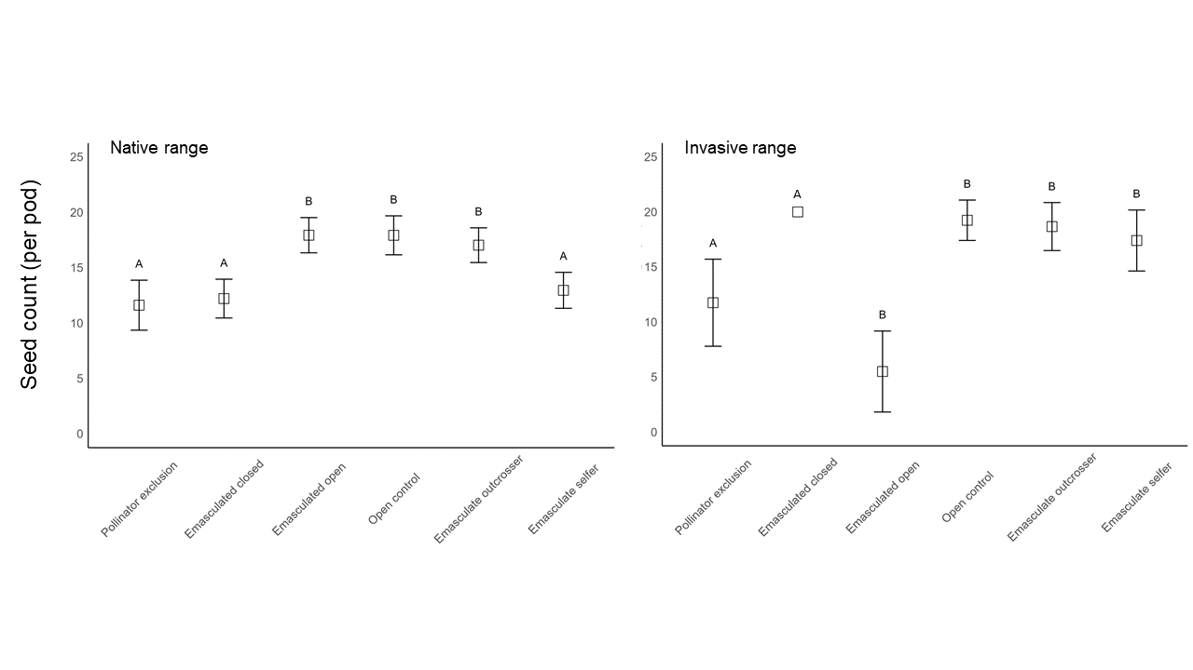**Figure S1 Mean (+-SE) count of seeds per pod after exposure to one of six manipulative pollination treatments. Data is pooled across sites within each range. Within each range, bars surmounted with different letters are significantly different, according to pairwise comparison where pollinator exclusion is the reference level after a generalised linear mixed model.**

**Table S1 *Senna obtusifolia* populations used in the study.**

|  |  |  |
| --- | --- | --- |
| **Population** | **Latitude** | **Longitude** |
| Trinity Beach QLD, Australia | -1343.54672 | 11654.73632 |
| White Rock QLD, Australia | -2377.614571 | 20405.26943 |
| Freshwater QLD, Australia | -1315.055979 | 11365.69191 |
| Barron River QLD, Australia | -16.86610636 | 145.6950007 |
| **Springvale, QLD, Australia** |  |  |
| **West Normanby River, QLD, Australia** |  |  |
| Chochola Municipality, Yucatan, Mexico | 1328.015122 | -5747.787663 |
| Xmatikuil, Yucatan, Mexico | 1877.237486 | -8066.311543 |
| Tekik de Regil, Yucatan, Mexico | 1956.339748 | -8420.450241 |

**Table S2.** Results from the generalised linear mixed models for each response variable in each range.

|  |  |  |  |  |  |  |  |
| --- | --- | --- | --- | --- | --- | --- | --- |
| **Response variable** | **Range** | **Effect** | **Estimate** | **St. dev** | **Chisq** | **DF** | **Pr(>Chisq)** |
| Fruit:flower ratio | Native | Site (random) | 1.63 | 1.28 |  |  |  |
| Fruit:flower ratio | Native | Treatment |  |  | 30.39 | 5 | <0.001 |
| Fruit:flower ratio | Invasive | Site (random) | 0.57 | 0.75 |  |  |  |
| Fruit:flower ratio | Invasive | Plant:site (random) | 0.08 | 0.28 |  |  |  |
| Fruit:flower ratio | Invasive | Treatment |  |  | 69.45 | 5 | <0.001 |
| Seed count (per flower) | Native | Treatment |  |  | 12.25 | 5 | 0.031 |
| Seed count (per flower) | Invasive | Site (random) | <0.001 | <0.001 |  |  |  |
| Seed count (per flower) | Invasive | Plant:site (random) | <0.001 | <0.001 |  |  |  |
| Seed count (per flower) | Invasive | Treatment |  |  | 33.12 | 5 | <0.001 |

**Table S3.** Tukey test outputs following generalised linear mixed model where native and invasive range data were analysed in two different models. The number of flowers that produced fruit was the response variable and the treatment applied was the fixed effect.

|  |  |  |  |  |  |  |
| --- | --- | --- | --- | --- | --- | --- |
| **Contrast** | **Range** | **estimate** | **SE** | **df** | **z.ratio** | **p.value** |
| Emasculate outcrosser - Emasculate selfer | Native | -4.93E-01 | 0.457 | Inf | -1.079 | 0.89 |
| Emasculate outcrosser - Emasculated closed | Native | 1.17E+00 | 0.435 | Inf | 2.7 | 0.0752 |
| Emasculate outcrosser - Emasculated open | Native | -3.52E-01 | 0.436 | Inf | -0.808 | 0.9662 |
| Emasculate outcrosser - Open control | Native | 4.10E-06 | 0.427 | Inf | 0 | 1 |
| Emasculate outcrosser - Pollinator exclusion | Native | 1.44E+00 | 0.448 | Inf | 3.209 | 0.0168 |
| Emasculate selfer - Emasculated closed | Native | 1.67E+00 | 0.465 | Inf | 3.584 | 0.0046 |
| Emasculate selfer - Emasculated open | Native | 1.41E-01 | 0.465 | Inf | 0.303 | 0.9997 |
| Emasculate selfer - Open control | Native | 4.93E-01 | 0.457 | Inf | 1.079 | 0.89 |
| Emasculate selfer - Pollinator exclusion | Native | 1.93E+00 | 0.478 | Inf | 4.043 | 0.0008 |
| Emasculated closed - Emasculated open | Native | -1.53E+00 | 0.447 | Inf | -3.42 | 0.0082 |
| Emasculated closed - Open control | Native | -1.17E+00 | 0.435 | Inf | -2.7 | 0.0752 |
| Emasculated closed - Pollinator exclusion | Native | 2.63E-01 | 0.451 | Inf | 0.584 | 0.9921 |
| Emasculated open - Open control | Native | 3.52E-01 | 0.436 | Inf | 0.808 | 0.9662 |
| Emasculated open - Pollinator exclusion | Native | 1.79E+00 | 0.459 | Inf | 3.896 | 0.0014 |
| Open control - Pollinator exclusion | Native | 1.44E+00 | 0.448 | Inf | 3.209 | 0.0168 |
| Emasculate outcrosser - Emasculate selfer | Invasive | 0.904 | 0.415 | Inf | 2.181 | 0.2467 |
| Emasculate outcrosser - Emasculated closed | Invasive | 4.043 | 0.696 | Inf | 5.813 | <.0001 |
| Emasculate outcrosser - Emasculated open | Invasive | 2.19 | 0.46 | Inf | 4.761 | <.0001 |
| Emasculate outcrosser - Open control | Invasive | 1.502 | 0.415 | Inf | 3.624 | 0.0039 |
| Emasculate outcrosser - Pollinator exclusio | Invasive | 3.538 | 0.518 | Inf | 6.835 | <.0001 |
| Emasculate selfer - Emasculated closed | Invasive | 3.139 | 0.673 | Inf | 4.663 | <.0001 |
| Emasculate selfer - Emasculated open | Invasive | 1.286 | 0.432 | Inf | 2.973 | 0.0349 |
| Emasculate selfer - Open control | Invasive | 0.598 | 0.387 | Inf | 1.546 | 0.6344 |
| Emasculate selfer - Pollinator exclusion | Invasive | 2.634 | 0.487 | Inf | 5.408 | <.0001 |
| Emasculated closed - Emasculated open | Invasive | -1.853 | 0.68 | Inf | -2.725 | 0.0703 |
| Emasculated closed - Open control | Invasive | -2.541 | 0.657 | Inf | -3.866 | 0.0015 |
| Emasculated closed - Pollinator exclusion | Invasive | -0.505 | 0.707 | Inf | -0.715 | 0.9802 |
| Emasculated open - Open control | Invasive | -0.688 | 0.414 | Inf | -1.662 | 0.5572 |
| Emasculated open - Pollinator exclusion | Invasive | 1.348 | 0.497 | Inf | 2.713 | 0.0727 |
| Open control - Pollinator exclusion | Invasive | 2.036 | 0.405 | Inf | 5.022 | <.0001 |

**Table S4.** Posthoc analyses after generalised linear mixed model where native and invasive range data were analysed in two different models. The count of seeds produced by each flower was the response variable and the treatment applied was the fixed effect. Invasive range posthoc was based on a Tukeys test and the native range pos hoc were based on select pairwise comparisons.

|  |  |  |  |  |  |  |
| --- | --- | --- | --- | --- | --- | --- |
| **Contrast** | **Range** | **estimate** | **SE** | **df** | **z.ratio** | **p.value** |
| Emasculate outcrosser - Emasculate selfer | Invasive | -0.15628 | 0.0832 | Inf | -1.877 | 0.4161 |
| Emasculate outcrosser - Emasculated closed | Invasive | 0.038181 | 0.4007 | Inf | 0.095 | 1 |
| Emasculate outcrosser - Emasculated open | Invasive | -0.03166 | 0.1822 | Inf | -0.174 | 1 |
| Emasculate outcrosser - Open control | Invasive | -0.15588 | 0.0757 | Inf | -2.058 | 0.3096 |
| Emasculate outcrosser - Pollinator exclusion | Invasive | 0.425075 | 0.1459 | Inf | 2.914 | 0.0416 |
| Emasculate selfer - Emasculated closed | Invasive | 0.194458 | 0.4028 | Inf | 0.483 | 0.9968 |
| Emasculate selfer - Emasculated open | Invasive | 0.124623 | 0.1878 | Inf | 0.664 | 0.9858 |
| Emasculate selfer - Open control | Invasive | 0.000394 | 0.0865 | Inf | 0.005 | 1 |
| Emasculate selfer - Pollinator exclusion | Invasive | 0.581352 | 0.1504 | Inf | 3.864 | 0.0016 |
| Emasculated closed - Emasculated open | Invasive | -0.06984 | 0.4349 | Inf | -0.161 | 1 |
| Emasculated closed - Open control | Invasive | -0.19406 | 0.3987 | Inf | -0.487 | 0.9966 |
| Emasculated closed - Pollinator exclusion | Invasive | 0.386894 | 0.4178 | Inf | 0.926 | 0.94 |
| Emasculated open - Open control | Invasive | -0.12423 | 0.1838 | Inf | -0.676 | 0.9846 |
| Emasculated open - Pollinator exclusion | Invasive | 0.45673 | 0.2239 | Inf | 2.04 | 0.3197 |
| Open control - Pollinator exclusion | Invasive | 0.580958 | 0.1381 | Inf | 4.205 | 0.0004 |
| Pollinator_exclusion_vs_Emasculate_selfer | Native | 0.1761 | 0.203 | Inf | 0.868 | 0.3856 |
| Pollinator_exclusion_vs_Emasculated_closed | Native | -0.0739 | 0.214 | Inf | -0.346 | 0.7296 |
| Pollinator_exclusion_vs_Emasculated_open | Native | -0.4414 | 0.19 | Inf | -2.32 | 0.0203 |
| Pollinator_exclusion_vs_Open_control | Native | -0.5029 | 0.193 | Inf | -2.61 | 0.0091 |
| Emasculate_outcrosser_vs_Pollinator_exclusion | Native | -0.4491 | 0.191 | Inf | -2.356 | 0.0184 |
| Pollinator_exclusion_vs_Emasculate_selfer | Native | 0.273 | 0.139 | Inf | 1.967 | 0.0492 |